Dear parents/ carers,
We have started our phonics learning in Chapter 2 with our scheme ‘Phonics Shed’. You may have already heard your children coming home talking about characters, sounds and actions. They have also been introduced to ‘Joe’ our phonics puppet, who you may also hear about!
We welcome your support at home to help the children consolidate their phonics learning, to be able to have a positive journey to becoming fantastic readers.
Below is a pronouciation guide for each sound to help you at home should you need it. This is the order in which we will learn the sounds and words.
Please be aware that we aim to reduce ‘schwa’ at the end of each sound- the ‘uh’ sound. Some sounds are ‘stretchy’ and some ‘bouncy’. The stretchy sounds are easiest to say ‘purely’ and the ‘bouncy’ sounds sometimes cannot be helped but have a small ‘schwa’ (which we should reduce as much as possible) at the end.
Grapheme  ‘How it is written’ | Phoeme  ‘How it is said’ | Pronunciation support | Character
s | ssss | stretchy | Sam the snake
a | ah ah ah ah | bouncy | Anna the ant
t | t t t t | bouncy | Tom the tiger
p | p p p p | bouncy | Pat the pig
i | i i i i | bouncy | Indy the imp
n | nnnn | stretchy | Noah the nurse
m | mmmm | stretchy | Monty the monkey
d | duh duh duh duh | bouncy | Dusty the dog
g | guh guh guh guh | bouncy | Grey the goat
o | o o o o | bouncy | Olly the Otter
c | c c c c  k k k k  c c c c | bouncy  these all make exactly the same sound | Curly the cat  Kit the kangaroo  Buck the duck
k | c c c c  k k k k  c c c c | bouncy  these all make exactly the same sound | Curly the cat  Kit the kangaroo  Buck the duck
ck | c c c c  k k k k  c c c c | bouncy  these all make exactly the same sound | Curly the cat  Kit the kangaroo  Buck the duck
e | eh eh eh eh | bouncy | Ellis the echidna
u | uh uh uh uh | bouncy | Ugby the bug
r | rrrr | stretchy | Rex the rat
h | h h h h | bouncy | Haz the hen
b | Buh buh buh buh | bouncy | Bumble the bee
f | ffff | stretchy | Flick the fly
l | llll | stretchy | Lily the ladybird
j | juh juh juh juh | bouncy | Jack the jungle explorer
v | vvvv | stretchy | Val the vet
w | wwww | stretchy | Wes the weasel
x | cks cks cks cks | bouncy | Alex the fox
y | yyyyy | stretchy | Yan the yoga teacher
z | zzzz | stretchy | Eliza the zebra
qu | qu qu qu qu | bouncy | Quinn the quail
‘s’ voiced | zzzz | stretchy  as in ‘bags’ frogs’ ‘beds’ | Additional sound for Sam the snake
‘a’ (ar) | arrrr | stretchy  as in Llama | Alana the Llama
ff | fffff | stretchy | Muffin the puffin
ll | lllll | stretchy | Billy the bull
ss | sssss | stretchy | Jess the grasshopper
zz | zzzzz | stretchy | Fizz the buzzard
tt | ttttt | stretchy | Lottie the bottle
pp | ppppp | stretchy | Pepper the hippo
rr | rrrrr | stretchy | Barry the parrot
mm | mmmmm | stretchy | Jimmy the hammer
cc | ccccc | stretchy | Rebecca the broccoli
nn | nnnnn | stretchy | Bonny the bunny
dd | ddddd | stretchy | Eddy the ladder
gg | ggggg | stretchy | Peggy the egg
bb | bbbbb | stretchy | Robby the gibbon
High Frequency Words
We will learn to read these high frequency words at speed in addition to blending sounds to read other words. Please note that some of them can be sounded out and blended but some of them are non decodable, which means children will need to be told the ‘tricky’ part of the word that doesn’t sound out typically.
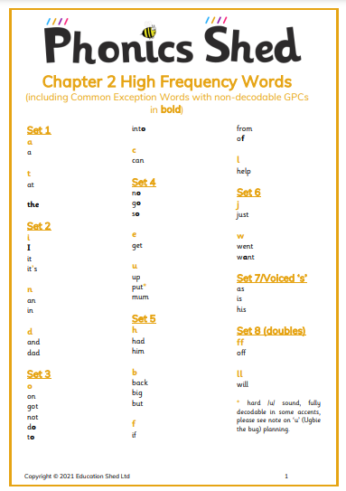
Please find your child’s log in to ‘Phonics Shed’/ ‘Ed Shed’ in their reading record. Please log in here to find some further activities to support phonics learning at home.
Happy phonic-ing,
Mrs Griffiths

