Flapjacks Recipe
Ingredients:
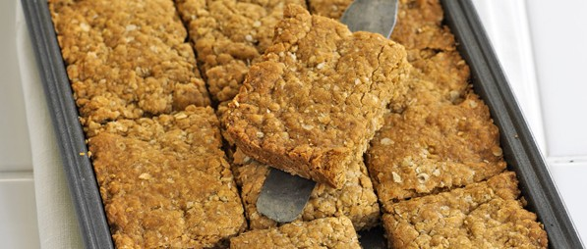
- 175g butter (diced)
- 175g soft light brown sugar
- 4 tablespoons golden syrup
- 350g whole porridge oats
- 50g corn flakes
Equipment:
- large saucepan
- wooden spoon
- 11-inch x 6-inch baking tin. (or use the closest tin size available)
- oven gloves
- knife
Method:
Step 1: Preheat the oven to 180C or gas 4. Ask an adult to help you.
Step 2: In a saucepan, gently melt the butter, sugar and golden syrup over a low heat. Stir with a wooden spoon until the sugar has dissolved. Ask an adult to help you when melting ingredients.
Step 3: Remove the saucepan from the heat and gently stir in the porridge oats and corn flakes with the wooden spoon. Stir until the mixture is thoroughly combined and sticky.
Step 4: Tip the mixture into the baking tin and spread out evenly with the back of the wooden spoon.
Step 5: Bake the mixture for 25 minutes or until golden and firm. Be careful not to cook it for too long. Always ask an adult to help you when putting in and taking out the tray from the oven.
Step 6: Remove from the oven using the gloves and allow to cool for 10 minutes.
Step 7: Once fully cooled, the mixture can be cut into bars. Remove from the tin and enjoy. Always ask an adult to help you when using a knife.

