Lemon Drizzle Cake Recipe
Ingredients:
- 115g margarine
- 170g caster sugar
- 170g self-raising flour
- 1 teaspoon baking powder
- 2 eggs
- 2 tablespoons lemon juice
- 2 tablespoons milk
- zest of 1 lemon
Equipment:
- 7-inch cake tin or a loaf tin
- electric or hand mixer
- wooden spoon
Toppings:
- juice of 1 lemon
- 115g granulated sugar
Method:
Step 1: Preheat the oven to 180C or gas 4. Ask an adult to help you.
Step 2: Line the cake tin with baking parchment or grease thoroughly with butter or margarine.
Step 3: Add all the ingredients to a mixing bowl and beat with an electric mixer or a wooden spoon. If you are using an electric mixer, always ask an adult to help you.
Step 4: Pour the mixture into the cake tin and bake for 30-35 minutes until well risen and shrinking away from the side of the tin. Ask an adult to help you when using the oven.
Step 5: Remove the cake from the oven (with adult assistance).

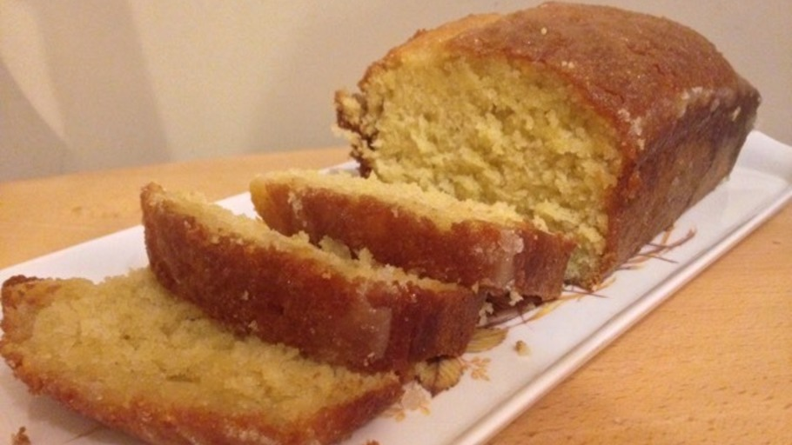
Step 6: Mix the lemon juice and granulated sugar together and pour over the cake while it is hot. Allow to cool in the tin.

