I | II | III | IV
  V | VI | VII | VIII
IX | X | XI | XII
XIII | XIV | XV | XVI
XVII | XVIII | XIX | XX
XXI | XXII | XXIII | XXIV
XXV | XXVI | XXVII | XXVIII
XXIX | XXX | XXXI | XXXII
XXXIII | XXXIV | XXXV | XXXVI
XXXVII | XXXVIII | XXXIX | XL
XLI | XLII | XLIII | XLIV
XLV | XLVI | XLVII | XLVIII
XLIX | L

Game instructions:
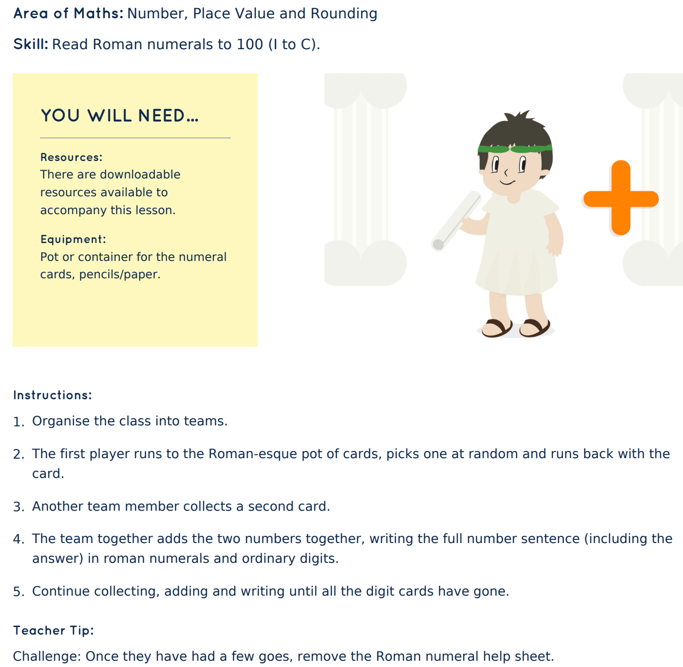

Help sheet – Roman numerals
