
Bee Spotting Grid

Fill in the names of flowers visited and when you saw the bee. When did you see the first bee of spring?

Type of bee
Honey bee

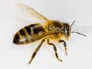
Common c arder b’bee

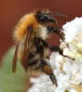

Red tailed b’bee

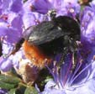
Early b’bee

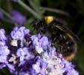

Buff tailed b’bee

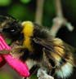



White tailed b’bee

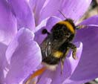

Garden b’bee

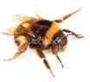

Other – did you see any other rarer species?

