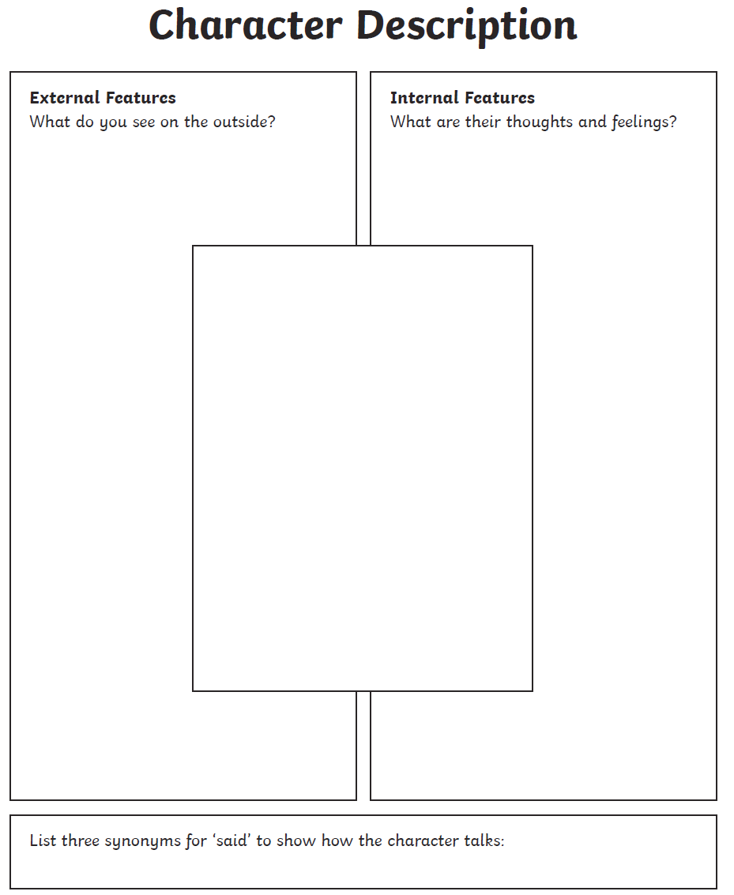
What is your character afraid of?
Draw your insect character:

Success criteria:
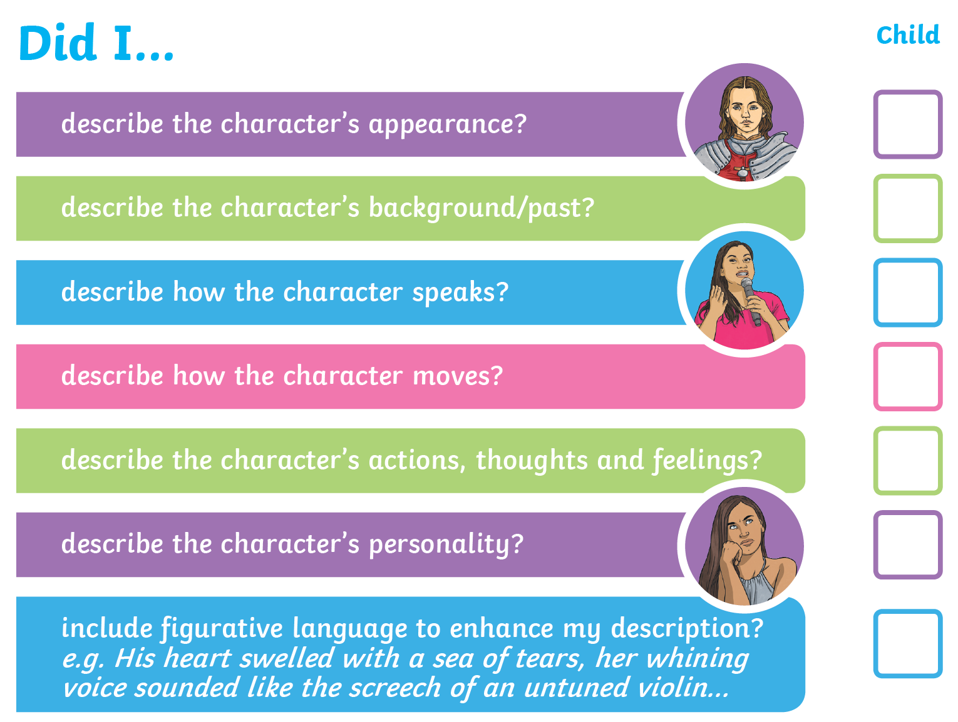
Some useful adjectives:
Remember in class we had a big focus on using:
-Fronted adverbials
-Expanded noun phrases
-Subordinate clauses
Can you use some of these?
