
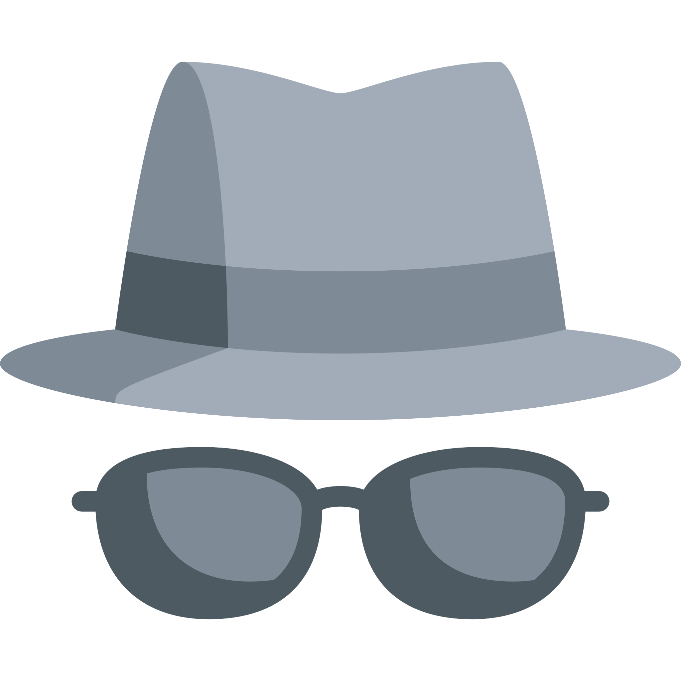
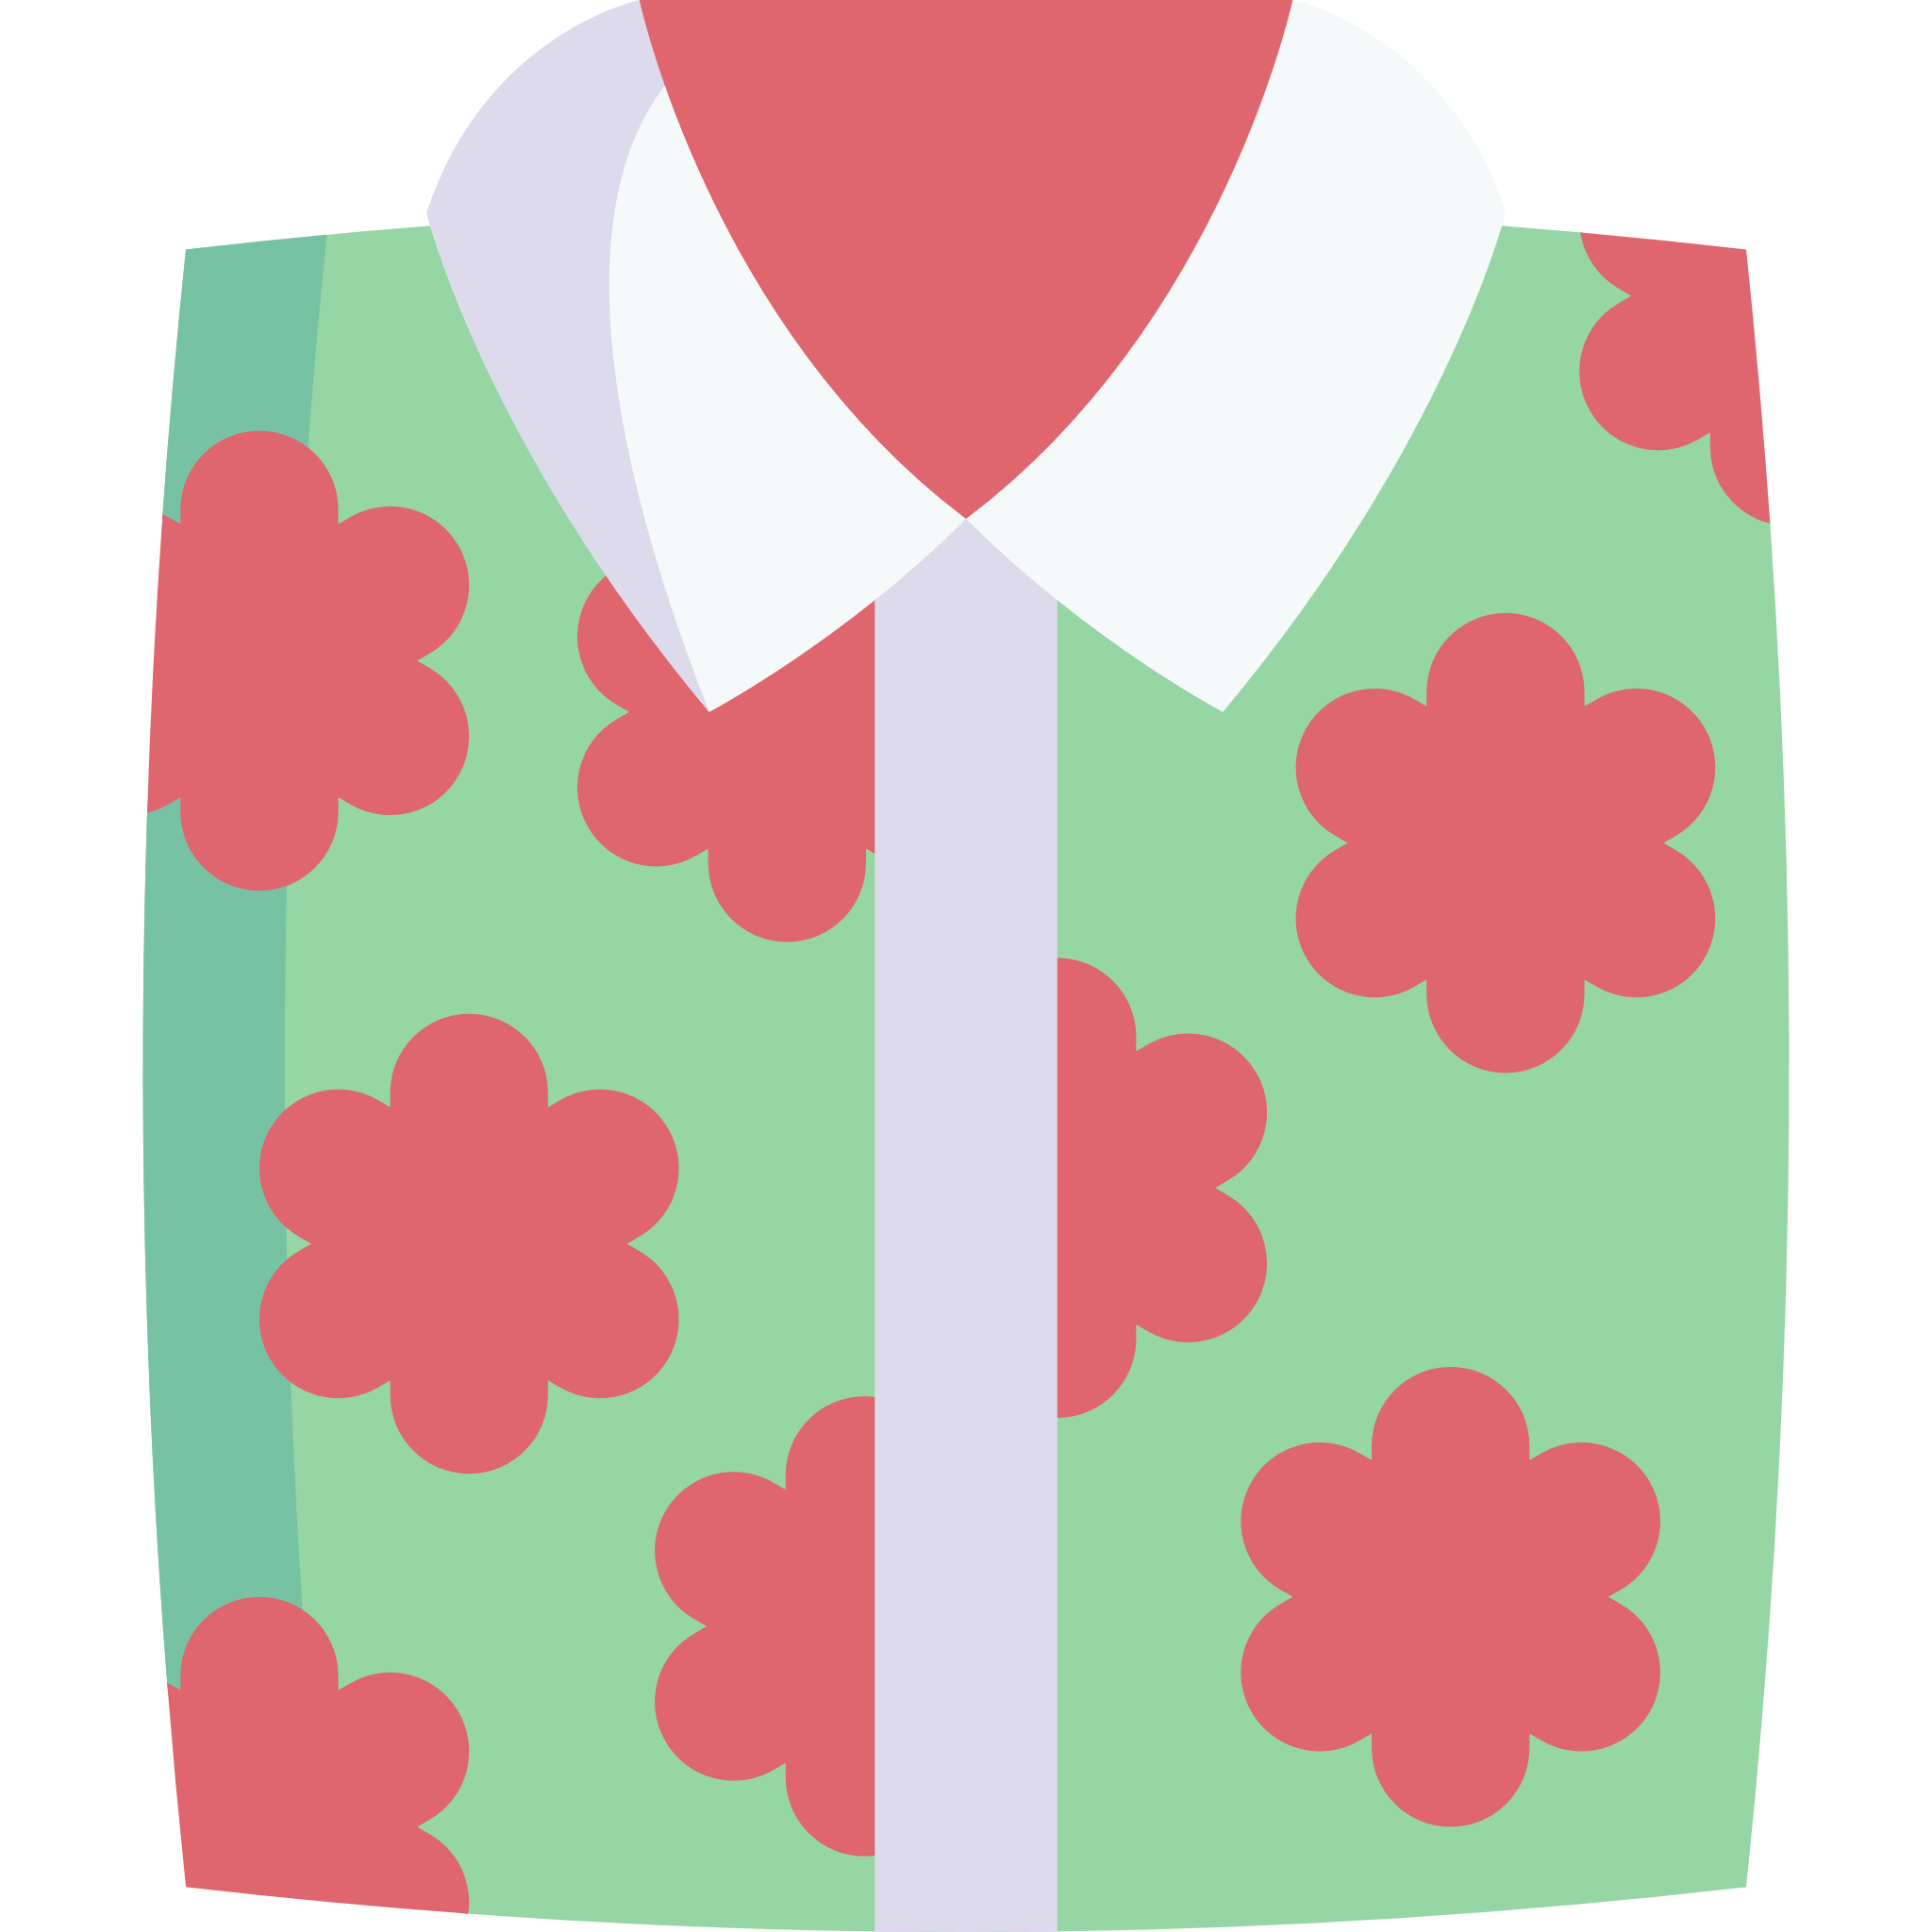
My Smart Outfit Design

Before you draw your design, think about:
- What occasion is your outfit going to be worn to?
- What colours will you use?
- Will you have a pattern on your outfit?
- What will the shoes look like?
- Will you have any accessories such as jewellery, a hat, scarf, bag, watch, glasses?

