LO: To use a question mark effectively.
Question marks
Can you put the question mark in the right place?
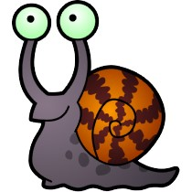

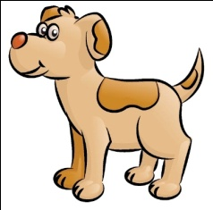

What is the dog’s name
What is the weather like
Can you tidy up please
What colour is that snail
Can you fill in the missing question word from the word bank?
______________ are you having for tea
How
What
______________ are you
Can
______________ you help me
Is
Who
______________ is coming to the party

