
Suitcase
If you travel on an aeroplane to another country, your suitcase has to be a certain size and a certain weight so they can fit it on. The length of the suitcase is usually measured in centimetres and the weight is usually measured in kilograms.

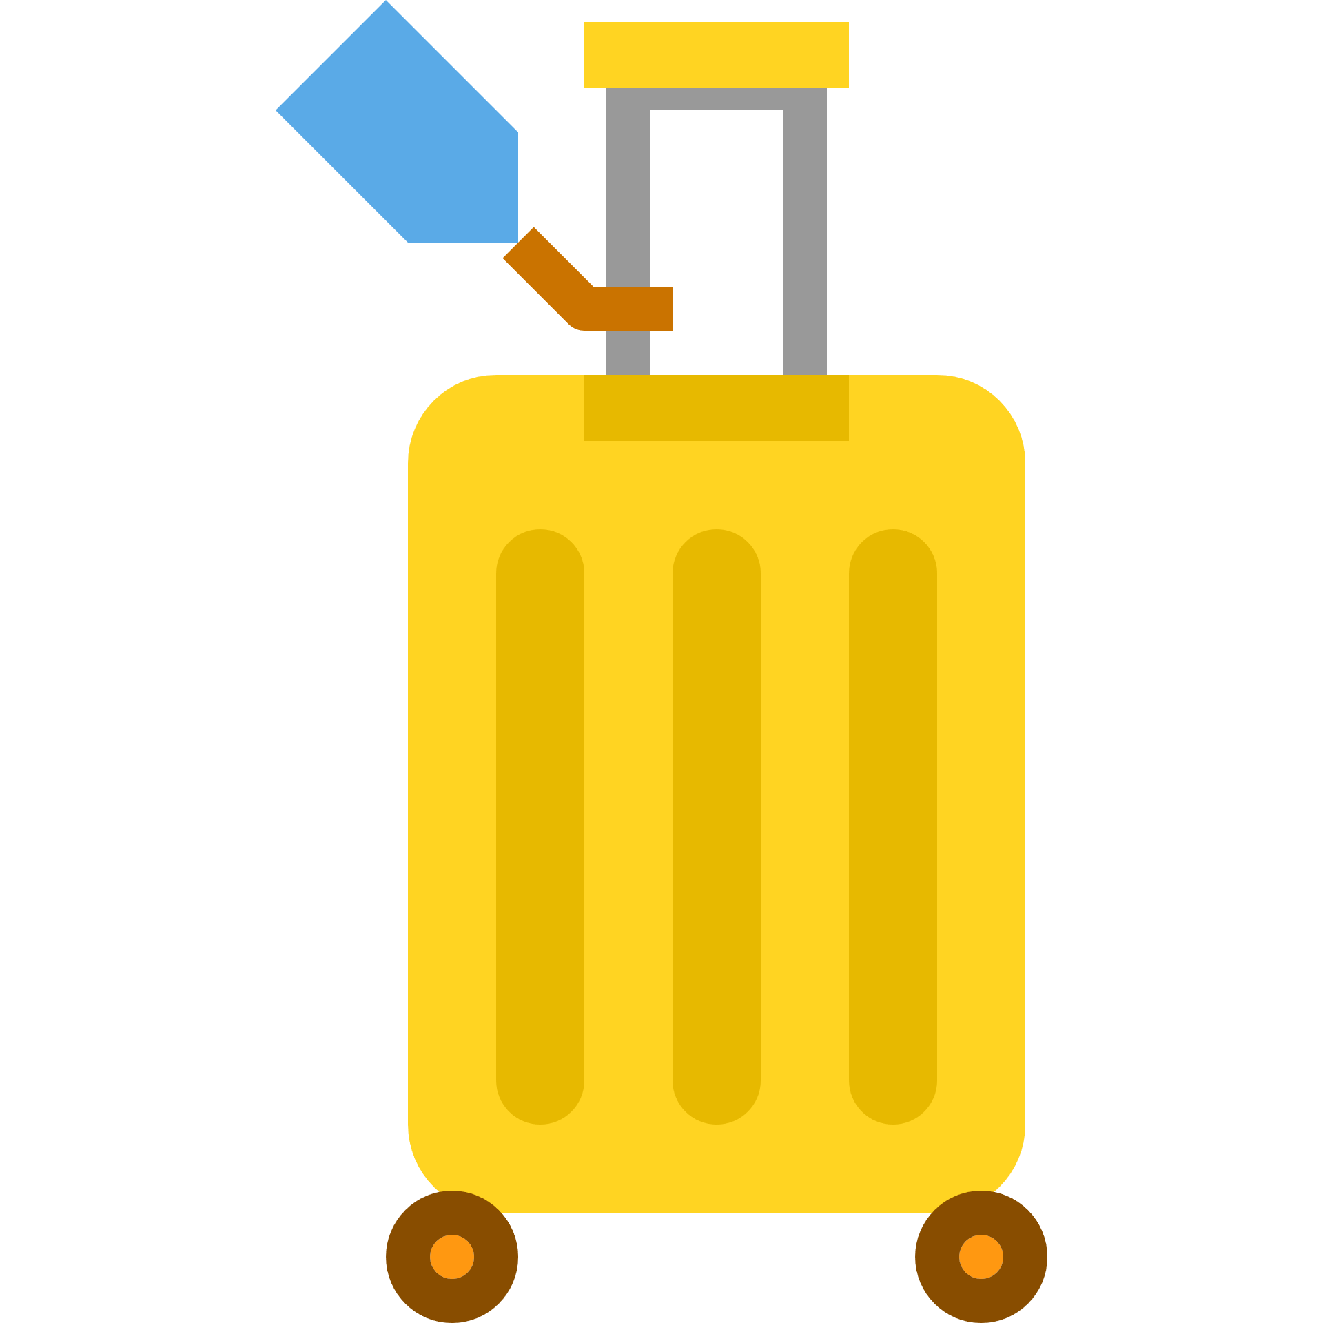
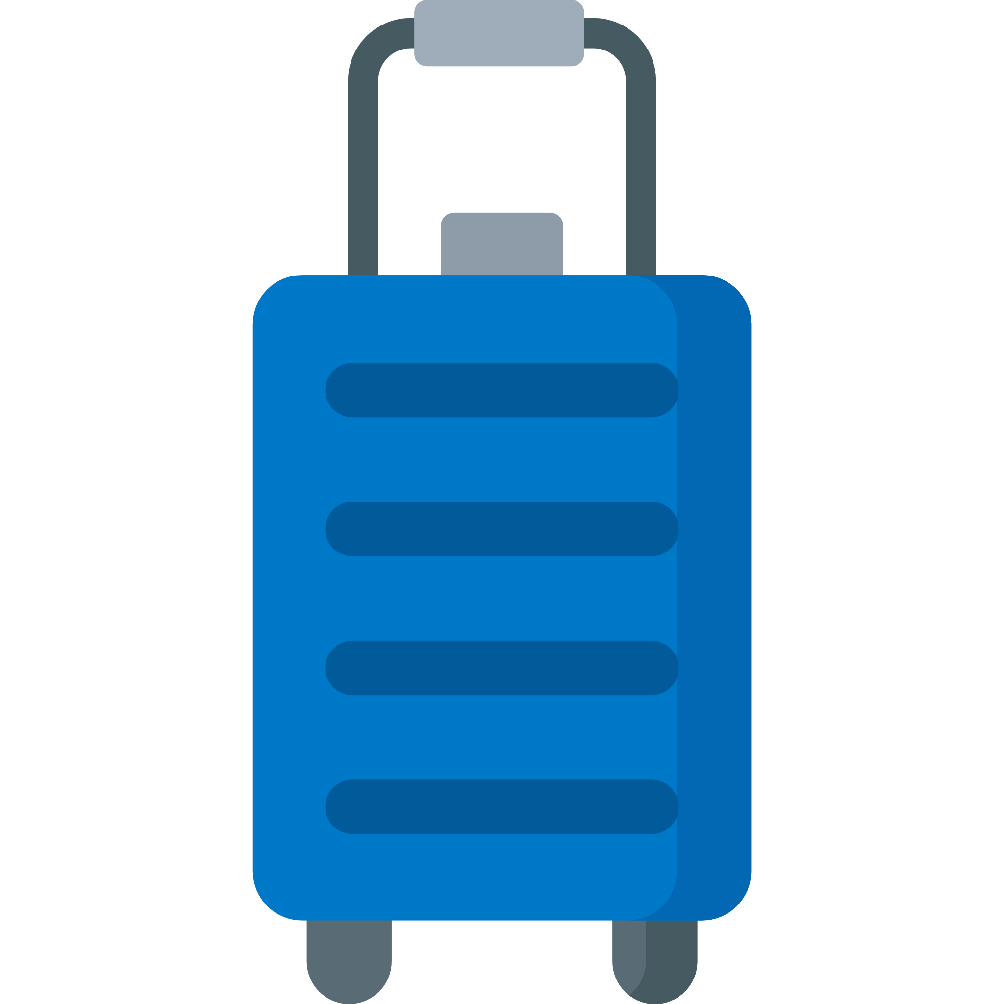


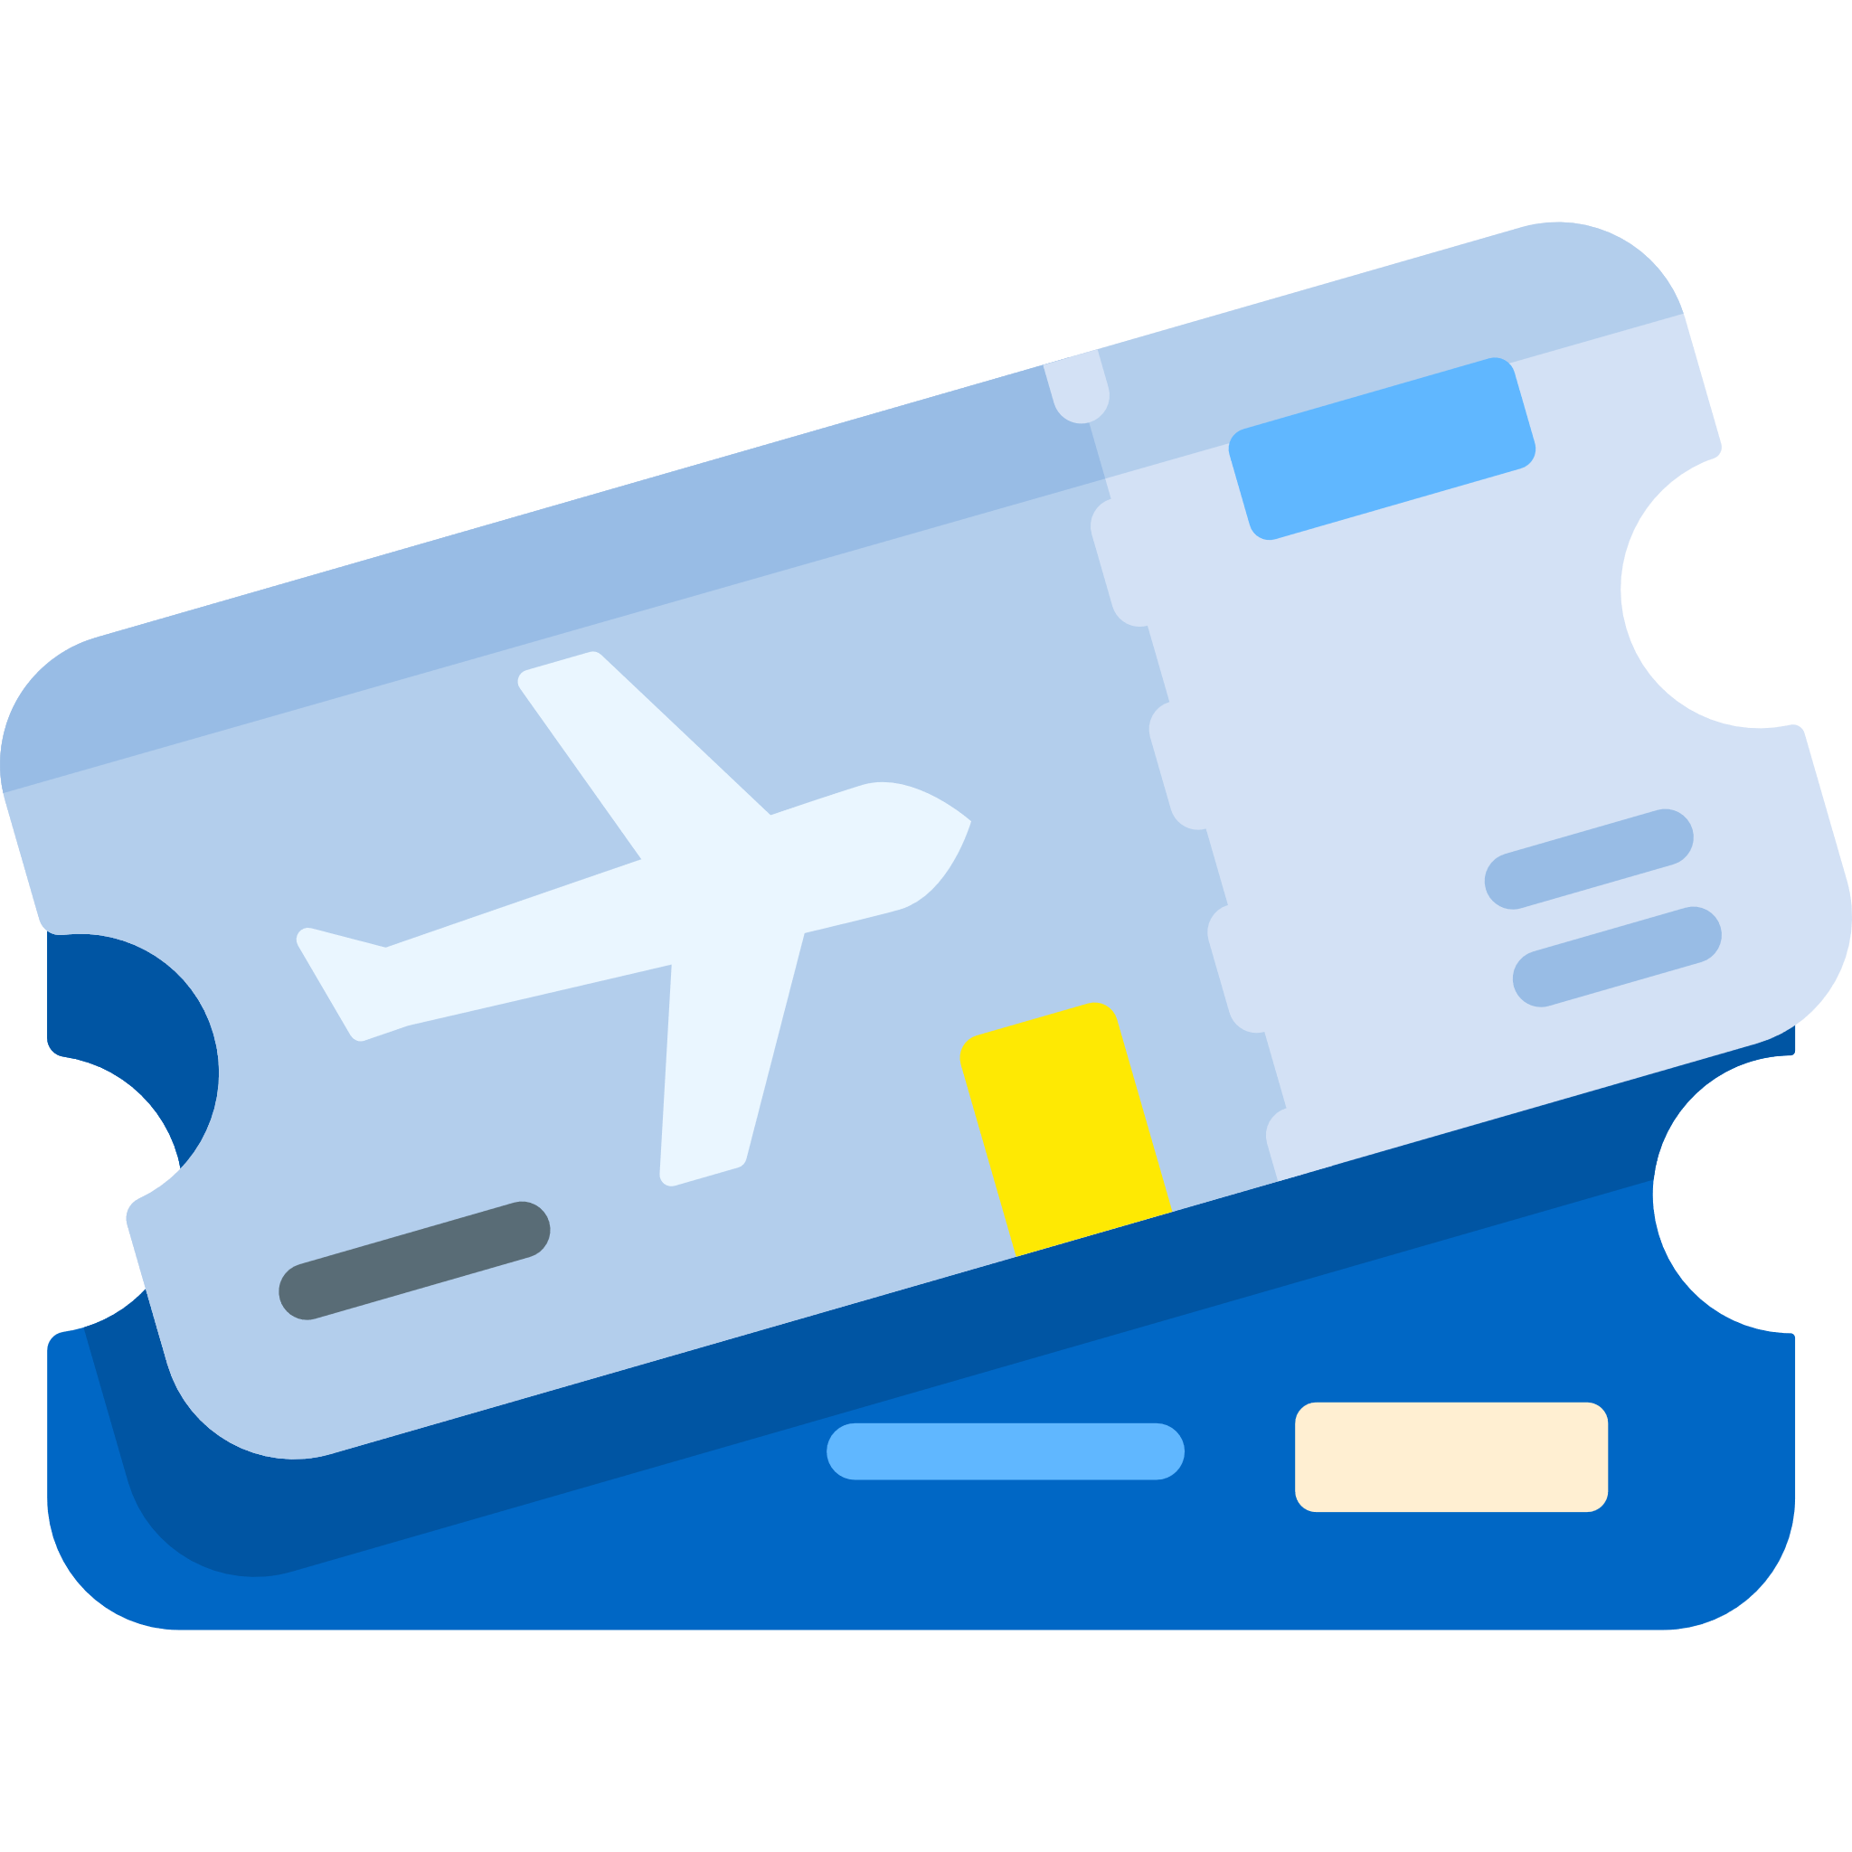

90cm
25cm
45cm
75cm
43cm
56cm
Checked-in suitcase size
Carry-on suitcase size
Weight – 32kg
Weight – 23kg
Look at the suitcase sizes below.
- What is the length of the checked-in suitcase?
- Can you find something in your home or classroom that is the same length as the carry-on suitcase?
- How much bigger is the width of the checked-in suitcase than the carry-on suitcase?
- Which suitcase is the heaviest?
- How much do you weigh? Is it more or less than each suitcase?
- Measure a suitcase or bag. Would you be able to take it on an aeroplane?

